

ASSIGNMENT-1

COMPUTER NETWORKS –ENCS304

Name: N. Yugesh
Roll Number: 2301010199
Course: BTech CSE – C
Date: 27th February 2026

Basic Network Topologies Using Switches and Hubs

Experiment Objectives:
In this practical experiment, three different LAN topologies are implemented using Cisco Packet Tracer to study their behavior and performance characteristics. The aim is to analyze how various network structures affect communication efficiency, reliability, and fault tolerance. Each end device is manually configured with an IPv4 address, and connectivity between devices is verified using ICMP ping commands.

Star Topology (Switch-Based LAN)
The star topology is one of the most commonly implemented network structures in present-day Local Area Networks (LANs). In this arrangement, all end devices are directly connected to a single central device, usually a network switch. The switch controls the communication process by forwarding frames only to the specific destination port, which improves overall network efficiency and minimizes unnecessary traffic.
One of the main advantages of this topology is simplified network management and easier troubleshooting. Since each device has a dedicated connection to the switch, identifying faults becomes straightforward. Additionally, performance is better compared to shared-medium networks such as hub-based designs. However, the major drawback is that the switch acts as a single point of failure — if it stops functioning, the entire network becomes unavailable.
In this experiment, a switch-based star topology was created in Cisco Packet Tracer to analyse IP configuration and verify communication using ICMP.
Network Setup:
- 1 Switch
- 4 PCs connected individually to the switch
Each PC was assigned a unique IPv4 address within the same network:
- 192.168.0.1
- 192.168.0.2
- 192.168.0.3
- 192.168.0.4
All devices were configured with the subnet mask 255.255.255.0.
After configuration, connectivity between devices was tested using the ping command to ensure successful communication.

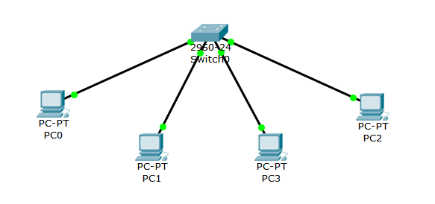

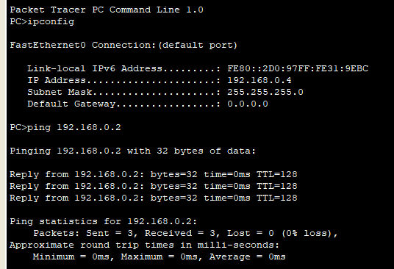

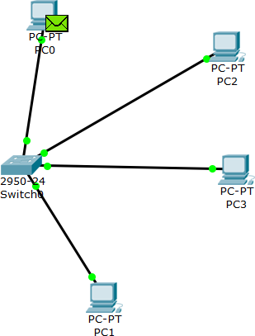

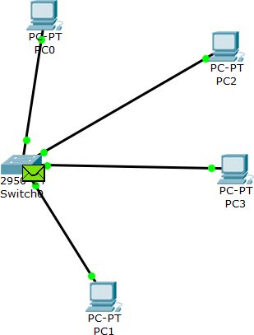

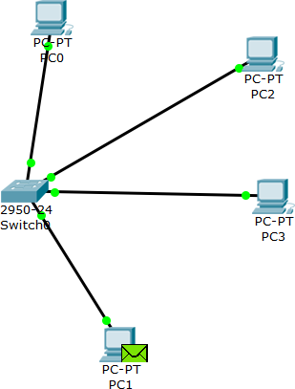

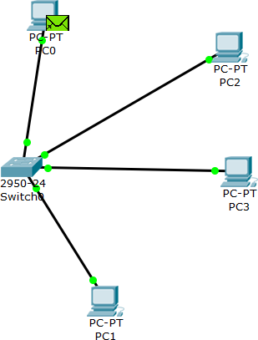

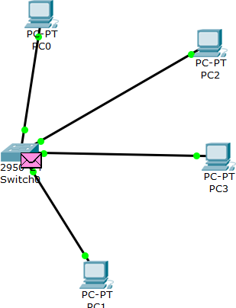

- Bus Topology (Hub-Based Network):
The bus topology is a shared communication model where all devices transmit data over a single common channel. In practical simulations using Cisco Packet Tracer, this type of behaviour is represented using a hub. A hub does not filter or direct traffic intelligently; instead, it sends incoming frames to all connected ports.
Unlike a switch, which forwards data only to the intended destination, a hub broadcasts every frame to every device in the network. Because all devices share the same communication medium, the chances of collisions increase significantly. This reduces overall network efficiency and performance.
Although bus-like networks are easy to set up and cost-effective for small environments, they are not suitable for larger networks due to scalability issues and higher traffic congestion.
In this experiment, a hub-based topology was implemented to analyse packet transmission behaviour. By observing simulation mode and performing ICMP ping tests, the differences between hub-based and switch-based communication were clearly identified, particularly in terms of broadcast traffic and collision handling.

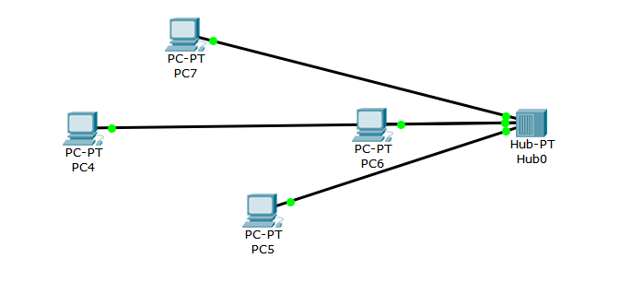
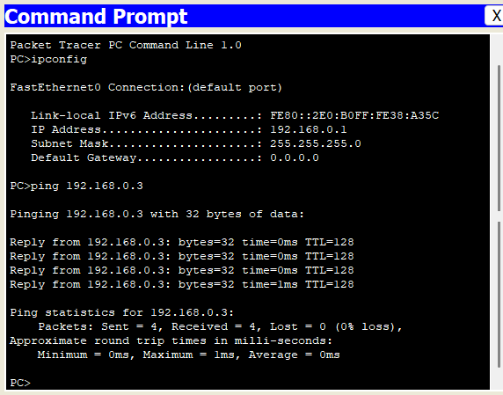

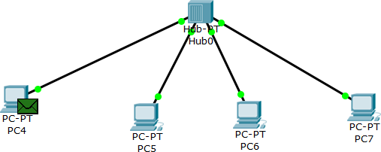

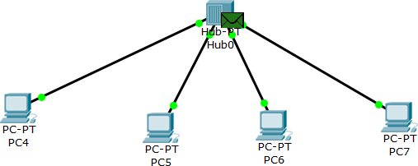

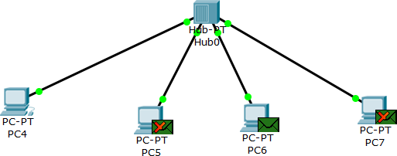



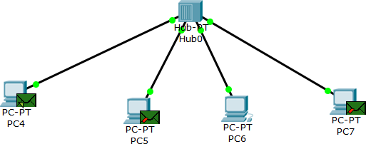

- Ring Topology (Loop-Based Switch Network):
The ring topology is a network structure in which devices are connected in a circular arrangement. In this configuration, each device is linked to two neighbouring devices, forming a closed communication loop. Data travels through intermediate nodes before reaching its intended destination, depending on the active path within the network.
Although this structure can provide redundancy by offering alternative paths for data transmission, it may also create problems such as switching loops and broadcast storms if not properly controlled. Therefore, loop prevention mechanisms are essential in such designs.
In this experiment, three switches were interconnected in a loop formation using Cisco Packet Tracer. Multiple PCs were distributed across the switches to study inter-switch communication. The setup was used to analyse how traffic flows between different segments of the network and how the system behaves during link failure conditions.
All PCs were assigned IPv4 addresses in the range:
192.168.0.1 to 192.168.0.8
Subnet Mask: 255.255.255.0
Connectivity between devices was verified using ICMP ping commands. The results demonstrated successful communication and highlighted the role of redundancy and fault tolerance in loop-based network structures.

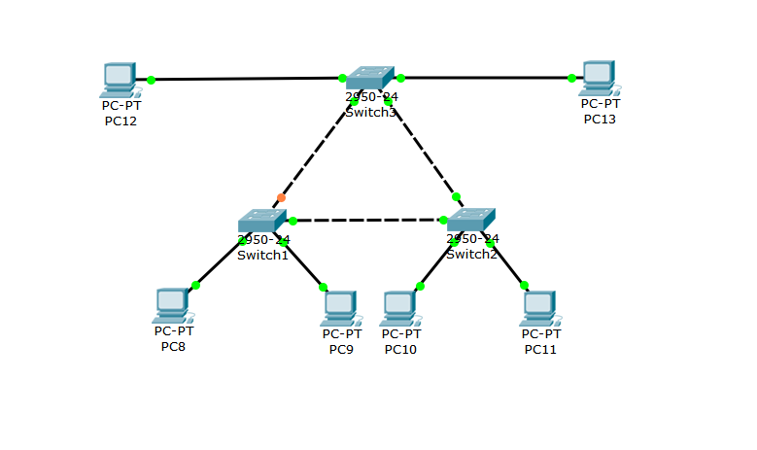
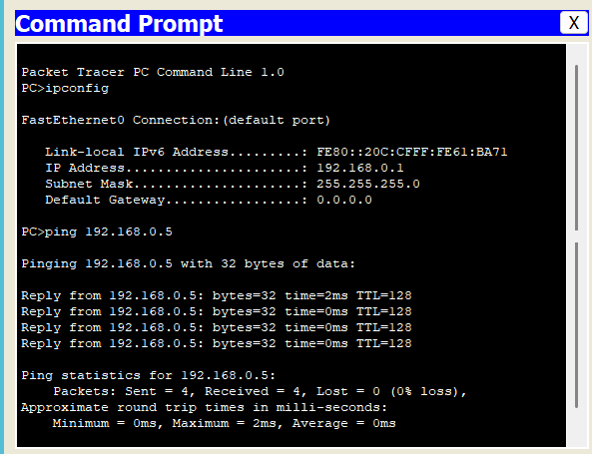

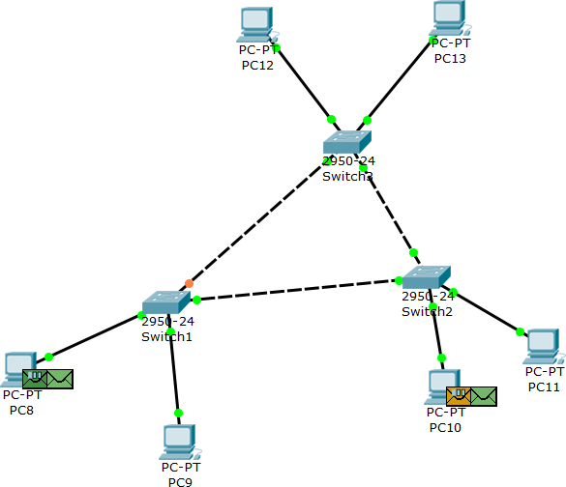

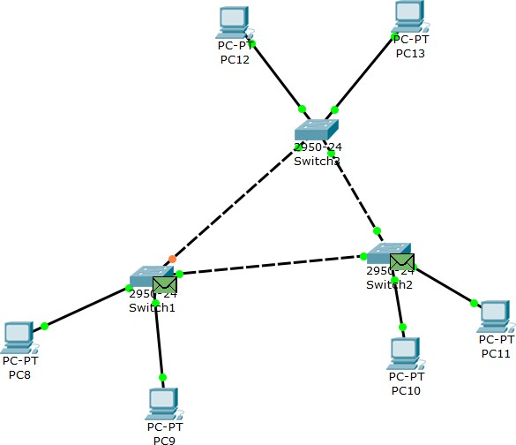

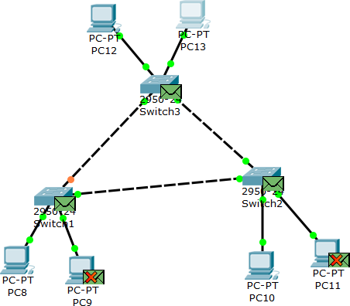

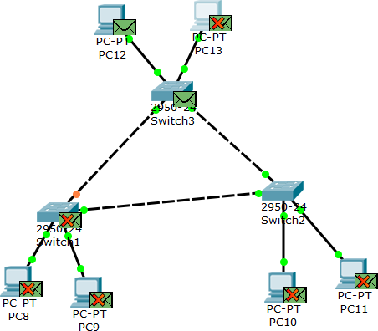

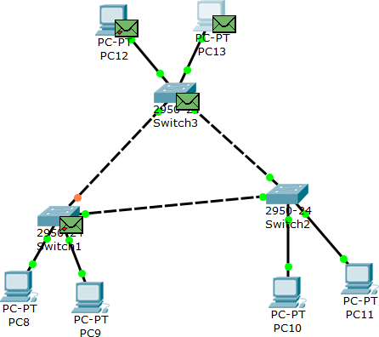

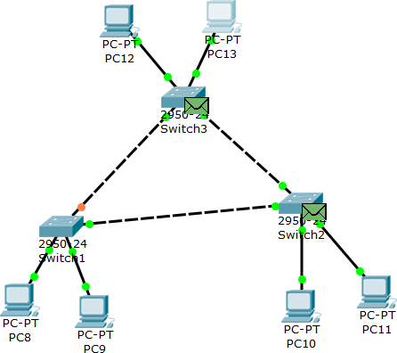

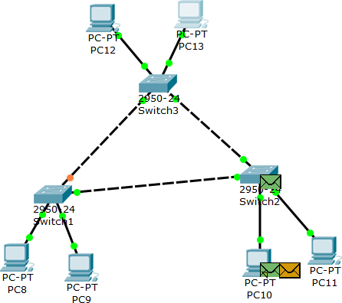

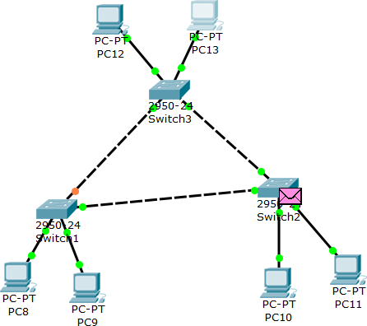

Failure Test (Link Failure Analysis)

Introduction

The failure test was performed to analyse how the network behaves when a physical link is intentionally disconnected. In LAN design, reliability and fault tolerance are very important because any link failure can directly affect communication between devices.
In this experiment, one of the inter-switch connections in the ring topology was manually removed to simulate a real-world link failure scenario. The objective was to observe whether communication between PCs would stop completely or continue through an alternate path.
By comparing ICMP ping results before and after removing the link, the impact of the topology on network availability was clearly observed. This test highlights key concepts such as redundancy, single point of failure, and the importance of proper network design.
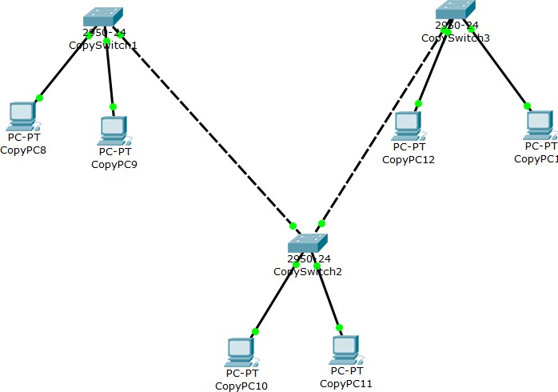
The results demonstrate how loop-based networks can maintain communication if alternate paths exist and proper control mechanisms are in place.

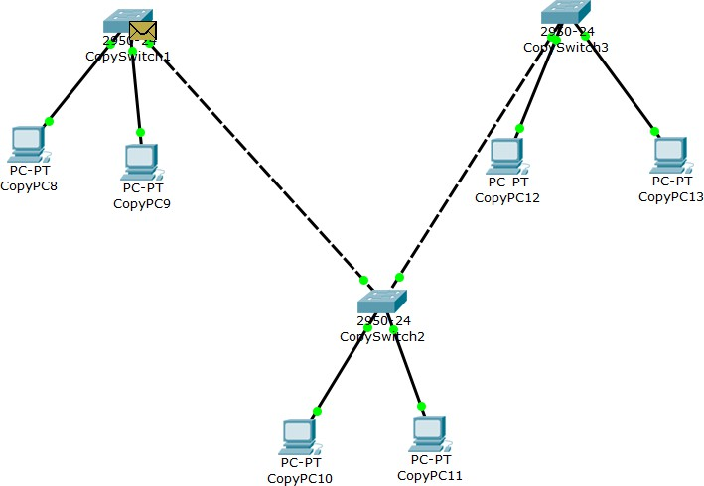
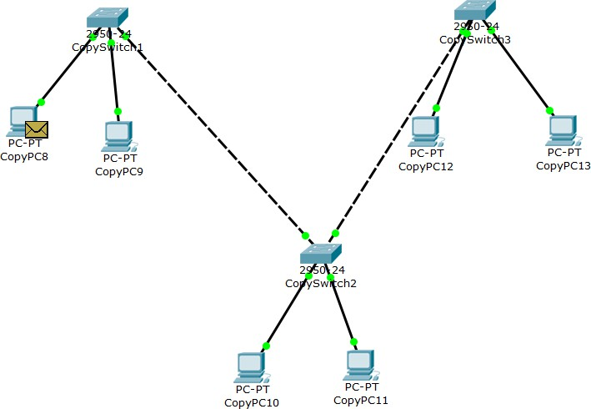

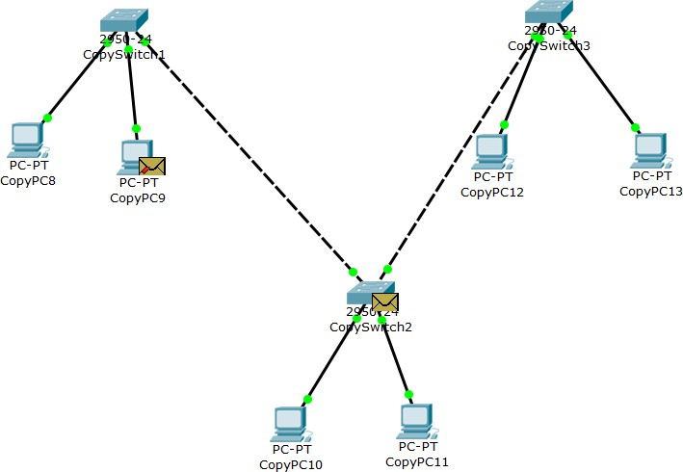
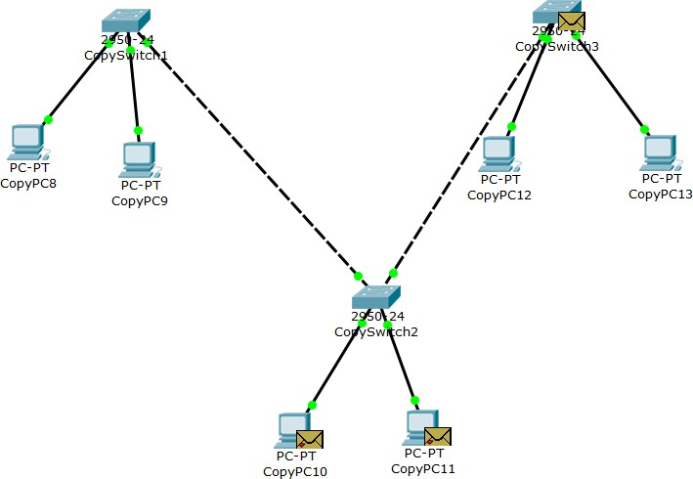

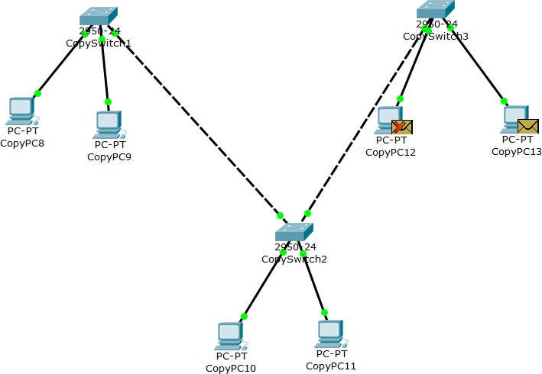
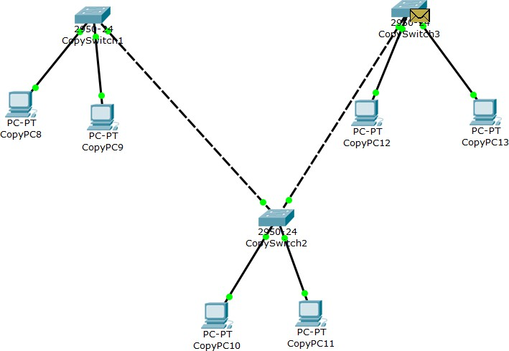

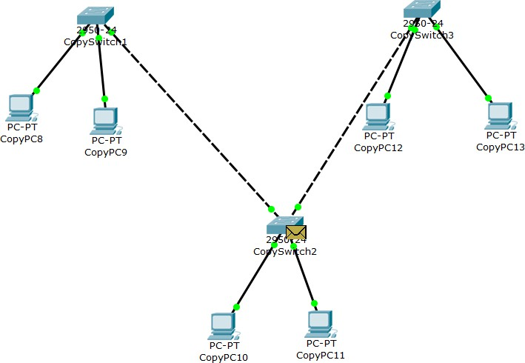


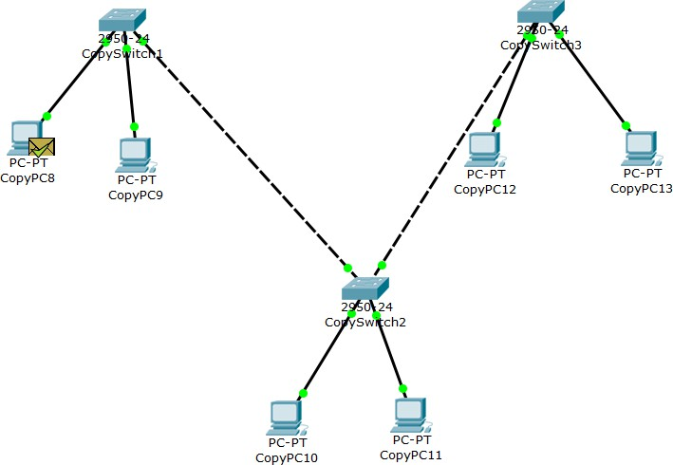

Observations – Comparison of Message Transfer in Different Topologies

Feature
Star Topology (Switch)
Bus-like Topology (Hub)
Ring-like Topology (Loop of Switches)

Packet Forwarding Method
Switch forwards frames only to the specific destination port using MAC address table.
Hub broadcasts incoming frames to all connected ports without filtering.
Frames are forwarded between switches based on MAC address learning.

Traffic Type
Mostly unicast traffic
Continuous
Traffic flows through

Observed in
after ARP resolution.
broadcast traffic to all intermediate switches

Simulation Mode
devices.
before reaching destination.

Collision Behavior
No collisions (separate collision domains per port).
High chance of collisions (single shared collision domain).
No collisions (switch-based), but possible loop-related broadcast issues.

Bandwidth Usage
Efficient utilization; only intended device receives data.
Inefficient; all devices receive every frame.
Moderate efficiency; depends on path and loop behavior.

ARP Behavior
Initial ARP broadcast, then direct unicast communication.
ARP broadcast visible on all ports.
ARP broadcast propagates across switches in the loop.

Ping Performance
Fast and stable responses.
Slower if multiple devices transmit simultaneously.
Stable unless loop causes excessive broadcast traffic.

Fault Tolerance
Failure of switch disconnects entire network.
Failure of hub
disconnects entire network.
If one link is removed, communication may still
continue through alternate path (depending on design).

Broadcast Storm Risk
Low Low
High if loop is not controlled (no STP).

Overall Network Efficiency
High Low
Moderate to High (but risky without loop control).

General Observations from Simulation Mode:
- In the switch-based star topology, frames are forwarded selectively based on MAC address learning. Only the intended destination device receives and processes the data, resulting in efficient communication.
- In the hub-based topology, every transmitted frame is broadcast to all connected devices. Even devices that are not the intended recipients receive the frame, which leads to unnecessary traffic and reduced efficiency.
- In the ring topology, data packets may pass through multiple intermediate switches before reaching the final destination. If loop prevention mechanisms are not implemented, frames can circulate repeatedly, causing excessive broadcast traffic.
- During the failure test, removing one inter-switch link helped evaluate network redundancy. The results showed whether communication was maintained through an alternate path or completely disrupted, highlighting the importance of proper topology design.

